# SANJALIKA WATERPARK SLIDE’S DESCRIPTION WITH MORE FEATURES

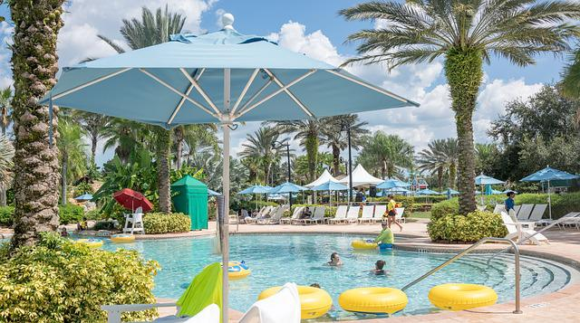

Figure sanjalika waterpark

Sanjalika Water Park is definitely an ultimate and out of the world source of entertainment. Decorated by mermaids, other statues, the Sanjalika Water park has largest cave and swimming pool area of modern technology a kind of place for thrills and fun. At Sanjalika Water park there is lot of water rides which are very exciting and thrilling.

In this document, you are gonna learn about more features of the slides with their information.

SUPER TORNADO SLIDE

Water parks are amusement parks that consist of lots of slides, playgrounds, swimming pools and lots of other areas which are full of water but are covered with various roundabouts. Water parks are mostly the favorite place to visit for every child and a lot of families during the summer visit various water parks as well. There are a lot of famous water parks around the world, and here a few of those water parks would be discussed where one can enjoy a **water park picnic** with his family.

FEATURES OF THE SUPER TORNADO SLIDE

Super tornado slide is an upgrade of the appearance and playing way of the waterslide products by Haisan according to the demand of market. It is the first water park equipment which combines sound, light and electric. The slide height is 21m and the cross section is 3m wide, its capacity is 4-6 person/raft. Tourists can ride on a slide of 3.0m wide, swing up and down the inner wall of the loudspeaker and join in it. Music, light, pearl curtain, water curtain, scream, etc. blend with each other, It seems that everything is perfect as if in a wonderful concert. Finally, as the height of the swing decreases gradually, it slides into the splash pool slowly. The whole process is breathtaking and exciting, which makes people forget to return

\

MORE FEATURES

|  |  |
| --- | --- |
| **Width** | 3m |
| **Capacity** | 4-6person/lane |
| **Platform height** | 21m |
| **Mats** | No |
| **Tubes** | Part |
| **Rafts** | Yes |
| **Production Method** | RTM |
| **Width** | 3m |
| **Capacity** | 4-6person/lane |

SUPER TORNADO SLIDE IMAGES

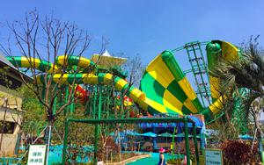

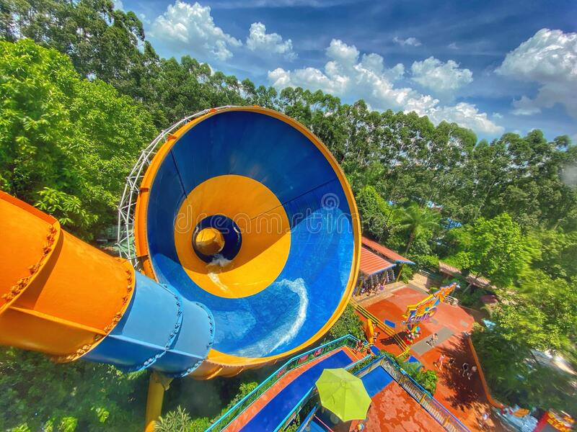

And many more images, customer feedback on such slides have always been good and keeps getting better.

Thank you!